Chapter 1. C# and .NET Programming
Learning C# introduces C# specifically, and the .NET development platform more generally, to programmers with little or no object-oriented programming experience. Along the way, you will learn a great deal about writing high-quality, industrial-strength programs for .NET.
This brief introduction will show you how C# fits into the .NET picture, what you can do with the language, and what benefits this language has over its predecessors.
You will also learn some of the concepts integral to object-oriented programming, which has revolutionized how web and Windows applications are developed. Object-oriented programming is closely tied to the semantics of the C# language, that is, the meaning behind the code you write. Obviously, you need to have a basic understanding of the syntax of the C# language, but you also need to understand what you are actually trying to accomplish.

1.1 C# and .NET
In the past, you might have learned a language like C or Java without much concern about the platform on which you would be programming. These cross-platform languages were as comfortable on a Unix box as they were on a PC running Windows.
C#, however, was created specifically for .NET. While .NET may become cross-platform some day soon — a Unix port is reportedly in the offing — for now the overwhelming majority of .NET programs will be written to run on a machine running .NET. At the time of this writing, that means a Windows machine.

1.2 The .NET Platform
When Microsoft announced C# in July 2000, its unveiling was part of a much larger event: the announcement of the .NET platform. The .NET platform is a development framework that provides a new way to create Windows applications. However, .NET goes beyond traditional Windows programming to facilitate creating web applications quickly and easily.
Microsoft says it is devoting 80% of its research and development budget to .NET and its associated technologies. The results of this commitment are impressive. For one thing, the scope of .NET is huge. The platform consists of three separate product groups:
- A set of languages, including C# and Visual Basic .NET; a set of development tools, including Visual Studio .NET; and powerful tools for building applications, including the Common Language Runtime (CLR), a platform for compiling, debugging, and executing .NET applications.
- A set of .NET Enterprise Servers, formerly known as SQL Server 2000, Exchange 2000, BizTalk 2000, and so on, that provide specialized functionality for relational data storage, email, B2B commerce, etc.
- New .NET-enabled non-PC devices, from cell phones to game boxes.
The C# language can be used to develop three types of applications you can run on your Windows computer:
- Console applications, which display no graphics
- Windows applications, which use the standard Windows interface
- Web applications, which can be accessed with a browser
This book will focus primarily on the basics of the C# language, mostly using simple console applications to illustrate language fundamentals.

1.3 The .NET Framework
Central to the .NET platform is a development environment known as the .NET Framework. The Framework specifies how .NET programming constructs such as intrinsic types, classes, and interfaces are implemented. You will learn about these constructs in the chapters ahead.
The .NET Framework sits on top of any flavor of the Windows operating system. The most important components of the Framework are the Common Language Runtime (CLR), described in the preceding section, and the Framework Class Library (FCL), which provides an enormous number of predefined types or classes for you to use in your programs. You will learn how to define your own classes in Chapter 8. Complete coverage of all the FCL classes is beyond the scope of this book. For more information, see C# in a Nutshell (O'Reilly & Associates).

1.4 The C# Language
The C# language is disarmingly simple, but C# is highly expressive when it comes to implementing modern programming concepts. C# includes all the support for structured, component-based, object-oriented programming that one expects of a modern language built on the shoulders of C++ and Java.
A small team led by two distinguished Microsoft engineers, Anders Hejlsberg and Scott Wiltamuth, developed the C# language. Hejlsberg is also known for creating Turbo Pascal, a popular language for PC programming, and for leading the team that designed Borland Delphi, one of the first successful Integrated Development Environments for client/server programming.
The goal of C# is to provide a simple, safe, object-oriented, Internet-centric, high-performance language for .NET development. C# is simple because there are relatively few keywords. This makes it easy to learn and easy to adapt to your specific needs.
 | Keywords are special words reserved by the language that have a specific meaning within all C# programs. Keywords include if, while, and for. You'll learn about these keywords in the coming chapters.

C# is considered safe because it provides support in the language to find bugs early in the development process. This makes for code that is easier to maintain and programs that are more reliable.
C# was designed, from the very start, to support object-oriented programming. This book will explain not only how to write object-oriented programs, but also why object-oriented programming has become so popular. The short answer is this: programs are becoming increasingly complex, and object-oriented programming techniques help you manage that complexity.
C# was designed for .NET, and .NET was designed for developing web and web-aware programs. The Internet is a primary resource in most .NET applications.
Finally, C# was designed for professional high-performance programming.

1.5 The Structure of C# Applications
At the most fundamental level, a C# application consists of source code. Source code is human-readable text written in a text editor. A text editor is like a word processor, but it puts no special characters into the file to support formatting, only the text. A classic text editor is Notepad.
Example 1-1 shows an example of a very simple source code file.
Example 1-1. A source code file
namespace NotePad
{
class HelloWorld
{
// every console app starts with Main
static void Main()
{
System.Console.WriteLine("Hello world!");
}
}
}
This program is explained in detail in Chapter 2. For now, observe that the program itself is readable; it is in normal text. The words may be strange and the layout unusual, but there are no special characters — just the normal text produced by your keyboard.
Once you write your program in an editor, you must compile it. For that you need a compiler. You will learn how to use the C# compiler in Chapter 2. Once compiled, your program must be run and tested.
While you can perform all of these tasks using Notepad (or another text editor) and various command-line tools, your programming life will be much easier if you use the Integrated Development Environment (IDE) called Visual Studio .NET. VS.NET was designed with .NET development in mind and greatly simplifies the writing of C# program code.

1.6 The Development Environment
The Visual Studio .NET Integrated Development Environment provides enormous advantages to the C# programmer. This book tacitly assumes that you'll use Visual Studio .NET for your work. However, the discussion focuses more on the language and the platform than on the tools.
Nonetheless, Chapter 4 provides a good introduction to the IDE in some detail. Chapter 10 returns to the IDE to examine the debugger, which will help you find and correct problems in your code.

Chapter 2. Getting Started with C#
You can use C# to create three different types of programs:
- Web applications
- Windows applications
- Console applications
The .NET platform is web-centric. The C# language was developed to allow .NET programmers to create very large, powerful, high-quality web applications quickly and easily. The .NET technology for creating web applications is called ASP.NET.
ASP.NET, the next generation from ASP (Active Server Pages), is composed of two Microsoft development technologies: Web Forms and Web Services. While the development of fully realized web applications using these technologies is beyond the scope of this book, learning the basics of the C# language will certainly get you started in the right direction. C# is generally acknowledged to be the language of choice for ASP.NET development.
Typically, you'll create an ASP.NET application when you want your program to be available to end users on any platform (e.g., Windows, Mac, Unix). By serving your application over the Web, end users can access your program with any browser.
When you want the richness and power of a native application running directly on the Windows platform, alternatively you might create a desktop-bound Windows application. The .NET tools for building Windows applications are called Windows Forms; a detailed analysis of this technology is also beyond the scope of this book.
However, if you don't need a Graphical User Interface (GUI) and just want to write a simple application that talks to a console window (i.e., what we used to call a DOS box), you might consider creating a console application. This book makes extensive use of console applications to illustrate the basics of the C# language.
Web, Windows, and console applications are described and illustrated in the following pages.
Console applications
A console application runs in a console window, as shown in Figure 2-1. A console window (or DOS box) provides simple text-based output.
Figure 2-1. A console application
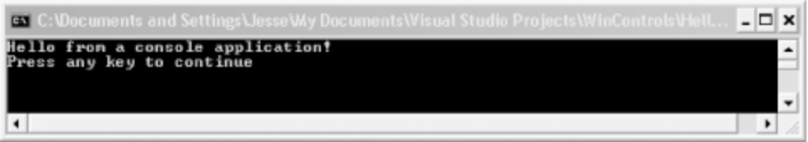
Console applications are very helpful when learning a language because they strip away the distraction of the Graphical User Interface. Rather than spending your time creating complex windowing applications, you can focus on the details of the language constructs, such as how you create classes and methods, how you branch based on runtime conditions, and how you loop. All these topics will be covered in detail in coming chapters.
Windows applications
A Windows application runs on a PC's desktop. You are already familiar with Windows applications such as Microsoft Word or Excel. Windows applications are much more complex than console applications and can take advantage of the full suite of menus, controls, and other widgets you've come to expect in a modern desktop application. Figure 2-2 shows the output of a simple windows application.
Figure 2-2. A Windows application
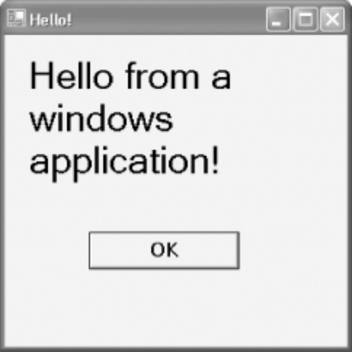
ASP.NET applications
An ASP.NET application runs on a web server and delivers its functionality through a browser, typically over the Web. ASP.NET technology facilitates developing web applications quickly and easily. Figure 2-3 shows a message from a simple ASP.NET application.
Figure 2-3. An ASP.NET application
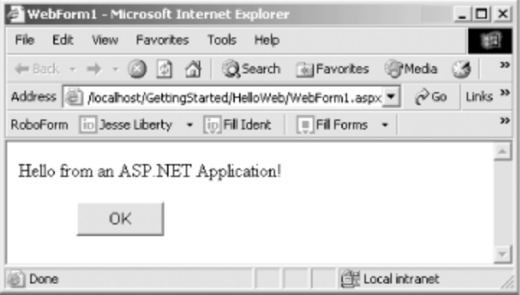
Although most commercial applications will be either Windows or ASP.NET programs, console applications have a tremendous advantage in a C# primer. Windows and ASP.NET applications bring a lot more overhead; there is great complexity in managing the window and all the events associated with the window. (Events are covered in Chapter 19.) Console applications keep things simple — allowing you to focus on the features of the language.
This book does not go into all the myriad details of building robust Windows and ASP.NET applications. For complete coverage of these topics, please see Programming ASP.NET and Programming .NET Windows Applications, both by Jesse Liberty and Dan Hurwitz (O'Reilly).

2.1 What's in a Program?
A program consists of English-language instructions called source code. The syntax for these instructions is strictly defined by the language. Source code consists of a series of statements. A statement is an instruction to the complier. Each instruction must be formed correctly, and one task you'll face when learning C# will be to learn the correct syntax of the language. For example, in C# every statement ends with a semi-colon.
Each instruction has a semantic meaning that expresses what you are trying to accomplish. Although you must follow the syntax, the semantics of the language are far more important in developing effective object-oriented programs. This book will provide insight into both the syntax and the semantics of good C# programs.
Save the source code you write in a text file. You can write this source code file using any simple text editor (such as Notepad), or you can use the Visual Studio .NET Integrated Development Environment (IDE). Visual Studio .NET is described in Chapter 4.
Once you write your program, you compile it using the C# compiler. The end result of compiling the program is an application.

2.2 Your First Program: Hello World
In this chapter, you will create a very simple application that does nothing more than display the words "Hello World" to your monitor. This console application is the traditional first program for learning any new language; it demonstrates some of the basic elements of a C# program.
Once you write your "Hello World" program and compile it, this chapter will provide a line-by-line analysis of the source code. This analysis gives something of a preview of the language; Chapter 5 describes the fundamentals much more fully.
As explained earlier, you can create C# programs with any text editor. You can, for example, create each of the three programs shown previously (in Figures 2-1, 2-2, and 2-3) with Notepad. To demonstrate that this is possible, you'll write your very first C# program using Notepad.
Begin by opening Notepad and typing in the program exactly as shown in Example 2-1.
Example 2-1. Hello World in Notepad
namespace NotePad
{
class HelloWorld
{
// every console app starts with Main
static void Main()
{
System.Console.WriteLine("Hello world!");
}
}
}
That is the entire program. Save it to your disk as a file called helloworld.cs.
We'll examine this program in some detail in just a moment. First, however, it must be compiled.
2.2.1 The Compiler
Once you save your program to disk, you must compile the code to create your application. Compiling your source code means running a compiler and passing in the source code file. You run the compiler by opening a command prompt (DOS box) and entering the program name csc. Then you pass in your source code file by entering the filename on the command line, as in the following:
csc HelloWorld.cs
The job of the compiler is to turn your source code into a working program. It turns out to be just slightly more complicated than that because .NET uses an intermediate language called Microsoft Intermediate Language (MSIL, sometimes abbreviated to IL). The compiler reads your source code and produces IL. The .NET Just In Time (JIT) compiler then reads your IL code and produces an executable application in memory.
Microsoft provides a command window with the correct environment variables set. Open the command window by selecting the following menu items in this order:
Start -> Programs -> Microsoft Visual Studio .NET
-> Visual Studio.NET Tools -> Visual Studio .NET Command Prompt
Then navigate to the directory in which you created your code file and enter the following command:
csc helloworld.cs
The Microsoft C# compiler compiles your code; when you display the directory you'll find the compiler has produced an executable file called helloworld.exe. Type helloworld at the command prompt, and your program executes, as shown in Figure 2-4.
Figure 2-4. Compiling and running Hello World
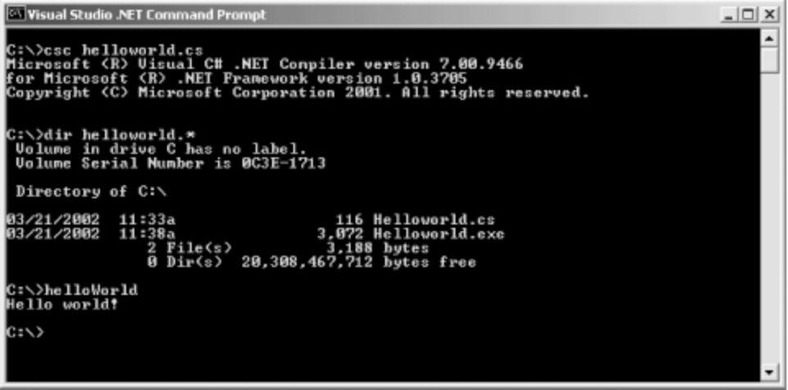
Presto! You are a C# programmer. That's it, close the book, you've done it. Okay, don't close the book — there are details to examine, but take a moment to congratulate yourself. Have a cookie.
Granted, the program you created is one of the simplest C# programs imaginable, but it is a complete C# program, and it can be used to examine many of the elements common to C# programs.

